***Women in Print: Recent Acquisitions* (working title)**

January 16–June 19, 2022

James and Hanna Bartlett Prints and Drawings Gallery

Britany Salsbury, PhD, Associate Curator Prints and Drawings

**Marketing Images and Captions:** [as of 4.19.2021]

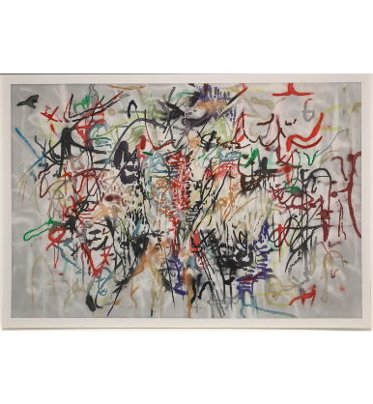

*Six Bardos: Hymn (Behind the Sun)*, 2018. Julie Mehretu (American, b. 1970). Color aquatint; image: 127.6 x 186.1 cm. The Cleveland Museum of Art, Purchase from the J. H. Wade Fund and partial gift of Stephen Dull, 2020.285. © Julie Mehretu

2020.285 Image Permissions: Marketing image - approved for non-commercial uses relating to exhibition and programs per BOS (4/2021)

______________________________________________________________________________

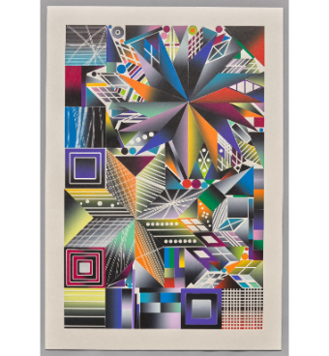  
*Atomic Mystic Cosmic 16*, 2017. Polly Apfelbaum (American, b. 1955). Woodblock; image: 81.7 x 53.5 cm. The Cleveland Museum of Art, Gift of Margaret and Peter Dobbins, 2020.273. © Polly Apfelbaum / Artists Rights Society (ARS), New York

2020.273 Image Permissions: Marketing image - approved for non-commercial uses relating to exhibition and programs per BOS (4/2021)



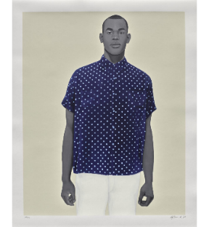

*Handsome*, 2020. Amy Sherald (American, b. 1973). Color screenprint; image: 102.2 x 81.3 cm. The Cleveland Museum of Art, Gift of the Print Club of Cleveland, 2020.277. © Amy Sherald

2020.277 Image Permissions: Marketing image - approved for non-commercial uses relating to exhibition and programs per BOS (4/2021)



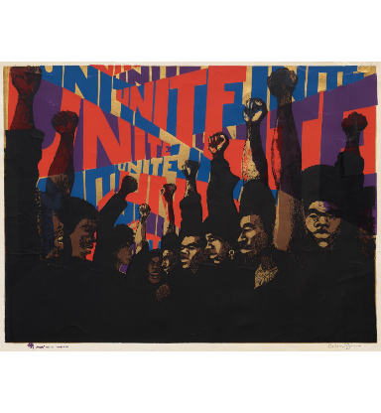  
*Unite*, 1969, printed 1971. Barbara Jones-Hogu (American, 1938–2017). Color screenprint; image: 56.9 x 76.7 cm. The Cleveland Museum of Art, Karl B. Goldfield Trust, 2021.14. © Barbara Jones-Hogu

2021.14 Image Permissions: Marketing image - approved for non-commercial uses relating to exhibition and programs per BOS (4/2021)

